THE ROE GROUP LTD. | 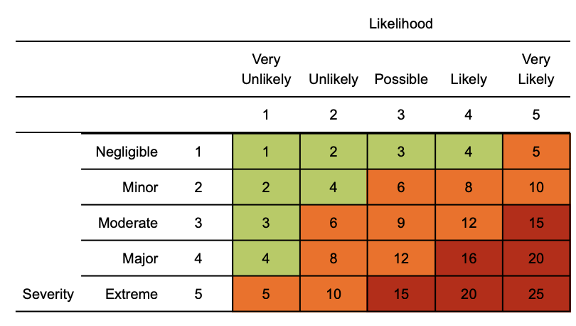  Risk matrix used in risk assessment below  RR = residual risk

(COVID-19) Risk Assessment

Assessment date: 04 MAY 2020.
Review date: 04 OCTOBER 2020.
Version: 1.1

Hazard | Risk | Control measures | RR | Persons at risk
Exposure from others due to:  1) Living with someone with a confirmed case of COVID-19.  2) Have come into close contact (within 2 metres for 15 minutes or more) with a confirmed case of COVID-19.  3) Being advised by a public health agency that contact with a diagnosed case has occurred. | 4  x  3  =  12 | - To follow government action of self-isolation and only to leave house on the following circumstances: for medical reason; to shop for necessary food supplies; for exercise per day; and for essential works including those deemed ‘key workers’  - Any existing individual risk assessments (disability, young persons or new / expectant mothers) to be reviewed.  - Maintain contact with Depot Managers and Head Office (HR) and to follow Roe Group policy / guidance.  - Travel is only required for essential travel; reduce the amount of time using public transport and to implement social distancing where possible (2m clearance from persons and not to travel in groups of more than 2 unless it is immediate family)  - To continue following ongoing government guidance  - Stay at home and only attend hospital in an emergency. Do not attend GP surgery and phone NHS line (111) if further advice is required  - Company to ensure extremely vulnerable persons (Solid organ transplant recipients; people with specific cancers: people with cancer who are undergoing active chemotherapy or radical radiotherapy for lung cancer; people with cancers of the blood or bone marrow such as leukaemia, lymphoma or myeloma who are at any stage of treatment; people having immunotherapy or other continuing antibody treatments for cancer; people having other targeted cancer treatments which can affect the immune system, such as protein kinase inhibitors or PARP inhibitors; people who have had bone marrow or stem cell transplants in the last 6 months, or who are still taking immunosuppressive drugs; People with severe respiratory conditions including all cystic fibrosis, severe asthma and severe COPD; People with rare diseases and inborn errors of metabolism that significantly increase the risk of infections (such as SCID, homozygous sickle cell); People on immunosuppression therapies sufficient to significantly increase risk of infection; Women who are pregnant with significant heart disease, congenital or acquired.) are shielding themselves and following their specific medical advice issued to them no later than 29/3/2020  - Follow good hygiene measures at all times  - Avoid all visitors to your home unless they are providing a medical requirement  - Do not approach delivery staff, allow packages to be left on the doorstep  - Do not take any antibiotics as they do not work against viruses. | 4  x  1  =  4 | Individual workers
Suspected case whilst working at depot. | 4  x  4  =  16 | If a worker develops a high temperature or a persistent cough while at work, they should:  - Return home immediately  - Avoid touching anything  - Cough or sneeze into a tissue and put it in a bin, or if they do not have tissues, cough and sneeze into the crook of their elbow.  - They must then follow the guidance on self-isolation and not return to work until their period of self-isolation has been completed. | 4  x  1  =  4 | Individual workers
General travel – access and egress | 4  x  4  =  16 | - Do not travel unless you cannot work from home or deemed a key worker – implement teleconferencing for meetings  - All persons to limit their use of public transport. Where travel is essential, please use private single occupancy where possible | 4  x  1  =  4 | Individual workers
Access / egress to site | 4  x  4  =  16 | Where possible, please consider and implement the following practices:  - Stop all non-essential visitors  - Introduce staggered start and finish times to reduce congestion and contact at all times  - Monitor site access points to enable social distancing – you may need to change the number of access points, either increase to reduce congestion or decrease to enable monitoring  - Require all workers to wash or clean their hands before entering or leaving the site  - Allow plenty of space (two metres) between people waiting to enter site  - Regularly clean common contact surfaces in reception, office, access control and delivery areas e.g. screens, telephone handsets, desks, particularly during peak flow times  - Drivers should remain in their vehicles if the load will allow it and must wash or clean their hands before unloading goods and materials. | 4  x  1  =  4 | Individual workers
Inclement weather – cold temperature allows disease to survive | 2  x  2  =  4 | - All persons to dress appropriately for the weather  - Welfare facilities provided to shelter from the elements  - Maintain good hygiene measures at all times  - Appropriate face coverings are recommended - It is advised that this could be useful and proper facemasks / supplies should be reserved for medical staff as it has been documented that supplies have been difficult to procure | 2  x  1  =  2 | Individual workers
Poor hygiene | 4  x  4  =  16 | - Wash your hands thoroughly and regularly. Use soap and water for at least 20 seconds. Use alcohol-based hand sanitiser if soap and water is not available and hand washing technique to be adopted as directed by PHE.  - Avoid touching your face/eyes/nose/mouth with unwashed hands and cover your cough or sneeze with a tissue then throw it in the bin.  - Provide additional hand washing facilities to the usual welfare facilities if a large spread out site or significant numbers of personnel on site  - Regularly clean the hand washing facilities and check soap and sanitiser levels  - Provide suitable and sufficient rubbish bins for hand towels with regular removal and disposal.  - Depots will need extra supplies of soap, hand sanitiser and paper towels and these should be securely stored.  - Restrict the number of people using toilet facilities at any one time. Wash hands before and after using the facilities - Enhance the cleaning regimes for toilet facilities particularly door handles, locks and the toilet flush. | 4  x  1  =  4 | Individual workers
Canteen - exposure from large numbers of persons | 4  x  4  =  16 | - The workforce should also be required to stay on site once they have entered it and not use local shops.  - Dedicated eating areas should be identified on site to reduce food waste and contamination  - Break times should be staggered to reduce congestion and contact at all times  - Hand cleaning facilities or hand sanitiser should be available at the entrance of any room where people eat and should be used by workers when entering and leaving the area  - The workforce should be asked to bring pre-prepared meals and refillable drinking bottles from home  - Workers should sit 2 metres apart from each other whilst eating and avoid all contact  - Drinking water should be provided with enhanced cleaning measures of the tap mechanism introduced  - Tables should be cleaned between each use  - All rubbish should be put straight in the bin and not left for someone else to clear up  - All areas used for eating must be thoroughly cleaned at the end of each break and shift, including chairs, door handles, vending machines and payment devices. | 4  x  1  =  4 | Individual workers
Use of Changing facilities, showers and drying rooms | 4  x  4  =  16 | - Introduce staggered start and finish times to reduce congestion and contact at all times  - Introduce enhanced cleaning of all facilities throughout the day and at the end of each day  - Consider increasing the number or size of facilities available on site if possible  - Based on the size of each facility, determine how many people can use it at any one time to maintain a distance of 2 metres  - Provide suitable and sufficient rubbish bins in these areas with regular removal and disposal. | 4  x  1  =  4 | Individual workers
Workplace / office layouts |  | - Workplace layouts to be looked at to see if minor adjustments can take place to ensure that people at workstations / desks are working at least 2 metres away from the next person

Training
Please ensure all staff and operatives have been alerted to company specific process / procedures.

Management
- Please ensure all staff are aware of reporting requirements and that all confirmed cases are escalated to your H&S competent person.
- Information notes are to be sent out and any updates communicated in a timely manner to the workforce.
- This must include letting staff know about symptoms and actions the medical professionals are advising people to take.
- A colleague who has been isolated for 14 days cannot return to work until the appropriate ‘fit note’ documentation is provided by their GP/healthcare provider to demonstrate they are now fit to return to work.
- Assessments to be reviewed every 6 months or where significant change has occurred

If in England call NHS on 111, if in Scotland call your GP or NHS 24, If in Wales call 0845 46 47 or 111 85 where you will be assessed by an appropriate specialist. NHS guidance is that you do not go directly to your GP surgery, community pharmacy or hospital unless an emergency occurs.

COMPILED BY – RICHARD BELL DATED – 07/05/2020.

